**This Week Around**

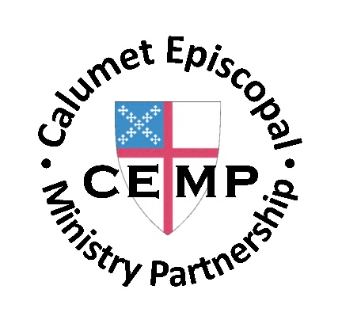

September 4 - 10, 2022



Wear Your Work Clothes to Church This Sunday!

To honor our varied careers—paid or volunteer—we invite you to wear your “work clothes” to church on this Sunday (Labor Day Weekend). Proudly claim the vocation through which God has called you to serve his people and creation.

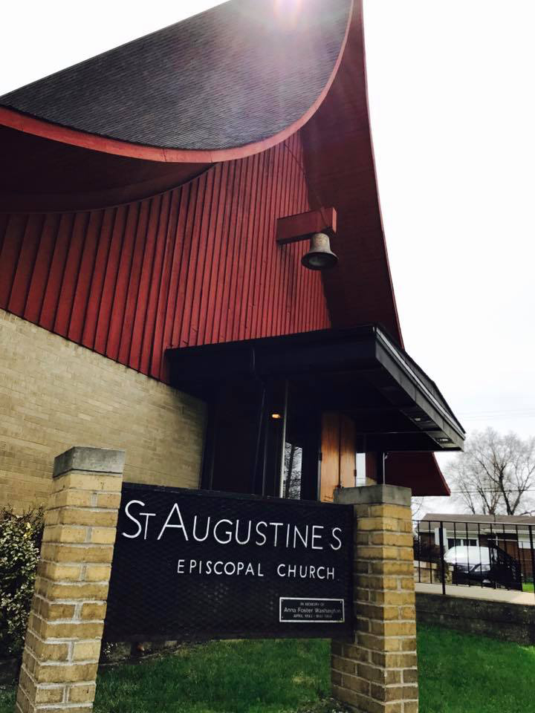

Congratulations, St. Augustine’s!

St. Augustine’s was one of nine sites significant to Indiana’s African American history to receive a grant from the Standiford H. Cox Fund and the Dovie Stewart Cox & Chester A. Cox, Sr., Memorial Fund. The funds were established by the late Standiford “Stan” Cox, an Eli Lilly chemist and preservation champion. St. Augustine’s is receiving $14,500 to install a high-efficiency furnace in their 1959 building. More information about these grants can be found at <https://www.indianalandmarks.org/2022/08/grants-help-to-preserve-nine-historic-african-american-sites-in-indiana/>.



Icon Writing

Pastor Kris has most graciously offered to create an icon of St. Christopher for St. Christopher’s Parish. The project will begin on Wednesday, September 7, at 11 a.m. Volunteers are needed to help with this enormous project, and we are asking for the help of all of CEMP. All are welcome: friends, relatives, and parishioners. You do not need any special talents; Pastor Kris will teach all skill levels.

We can adjust the schedule for other days and times as needed to accommodate those who wish to help. This Wednesday is just the starting date.

If you have any questions or want to schedule another time to help with the icon, please contact Bob Schrum at [bschrum@msn.com](mailto:bschrum@msn.com).



Our annual Pet Blessing service will be Sunday, October 9, at 2 p.m. at St. Stephen’s, Hobart. Please have your pets on leashes or in appropriate carriers. Children who have a favorite stuffed animal are also welcome to bring these special “pets” for a blessing as well.



N

Thank you once again to all volunteers helping with the St. Timothy Food Pantry. August was another busy month as we served 125 families and 538 individuals. The rain made it interesting.

We will still be outside for September, so here is the bagging and Pantry dates and times:

Bagging Day Thursday, September 8 12 noon – 2 or 3 p.m.

(Note the time change as the pick up crew is working about noon.

Pantry Day Saturday, September 17 8:30 a.m. – 12 noon

Please come and help even if you can only stay for a short time.

Bob Schrum

Food Pantry Director



  The annual Walk for Hunger is September 17 at the Lake County Fairgrounds. Can't make the walk? Donations can be made on behalf of our **CEMP Food Pantry.** Checks should be made payable to: **NWIFB,** with the memo: **TEAM ST TIMOTHY OF CEMP**.  Send checks to Pat Hamilton's attention at 3237 Saric Court 2K, Highland, IN 46322 or to: ST. Timothy, PO Box 347, Griffith, IN 46319. The need for food for Lake and Porter county residents is more than ever. If you have already donated, thank you.  More information is at  [foodbanknwi.org/hike.](http://foodbanknwi.org/hike.)  This is the time to make your donation count the most.

from Nolan . . .



Hello everyone!

I hope you are safe and well. I have kept you in my prayers as I have been settling into a new rhythm at Sewanee. As I am writing this (August 30) I am starting my second week of classes at the School of Theology. This semester I am taking five classes: Old Testament I, New Testament I, Foundations of Christian Spirituality, Global Anglicanism, and Beginning Pastoral Spanish. I am excited by my professors and am looking forward to what I will be learning this year.

One highlight from orientation was our group pilgrimage to Memphis. We were the first group in incoming students to be able to take this pilgrimage since the start of COVID. We started the day by visiting the National Civil Rights Museum. The museum is built around the Lorraine Motel, the site of Dr. Martin Luther King Jr.’s assassination. It was a powerful experience. We then visited the graves of the Martyrs of Memphis, a group of Episcopal nuns and priests who gave their lives caring for the sick during the city’s 1878 Yellow Fever epidemic. We celebrated the Eucharist at a chapel at the cemetery. Unfortunately, the air conditioning on our bus broke, but this gave us the opportunity to visit St. Mary’s Cathedral while we waited on a new bus to arrive to take us back to the seminary.

This year I am living in a community house with four other students: two priests from Malawi and one priest from Sri Lanka who are all in the MA program, and one other postulant from Colorado who is in the MDiv program like I am. We each have our own bedroom and bathroom but share a kitchen and living area. So far, we have been getting along well. We are planning to share a meal together every other week on Sunday evenings where one of us will cook for the others. Our first was last Sunday, and we shared a delicious meal and good fellowship. I am thankful to have such a good group of housemates.

Something I have particularly appreciated about Sewanee is the regular cycle of communal prayer. Most days Morning Prayer, Noonday Eucharist, and Evening Prayer are offered at the seminary chapel. The main exception is Thursday, when we have Morning Prayer and an evening family Eucharist. The Eucharist is celebrated in Spanish every second and fourth Tuesday of the month, and Evening Prayer is in Spanish every Wednesday. Wednesday is also the principal Eucharist for the seminary community, so it is celebrated at 11 and we share a meal afterwards. I have joined the seminary choir that sings at the Wednesday Eucharist. As a Junior (first year) I am scheduled to be a reader at services, and to help distribute the wine at the Eucharist. I ended up doing so at the first Eucharist of the semester. Officially we are supposed to attend at least one chapel service a day, but I am trying to order my schedule so I can attend all of them.

I am excited to see how the Spirit moves over the next three years I will spend at Sewanee. May God be with you.

In Christ,

Nolan McBride

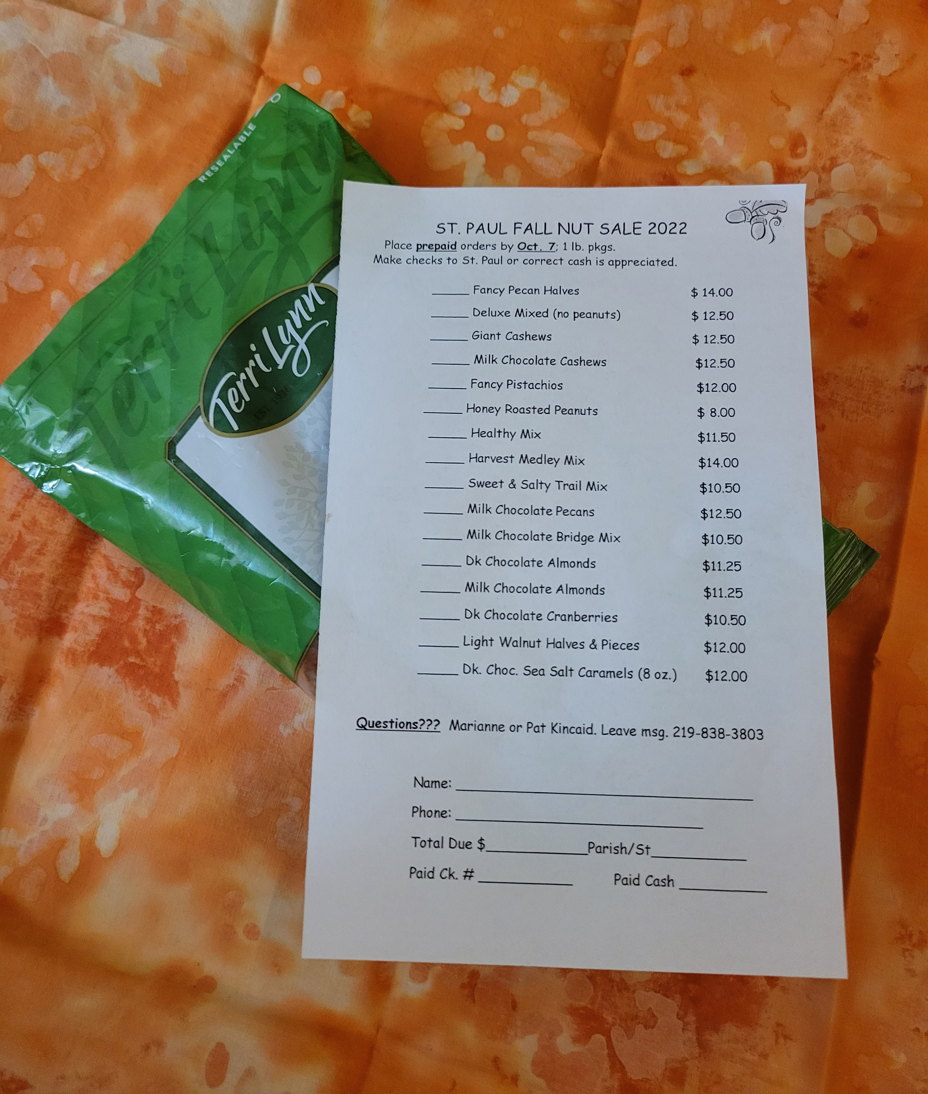

Volunteers Needed at Unity Hospice

Unity Hospice, serving northwest Indiana from their office in Merrillville, is looking for volunteers to visit terminally ill patients and/or perform office duties. They are also looking for pet companion volunteers with at least a Canine Good Citizen Certification. There are no time requirements; they provide opportunities based on your schedule. All are welcome: social or church groups, families, retirees, and students. If you would like to make a difference in the lives of others, sign up for an orientation session by calling Volunteer Coordinator Delaree Medley at 219-769-8648 or 219-314-8615.



**September 4 – James Coffin**

**September 5 – Cindy Croyle**

**September 6 – Michael Strowhorn**

**September 7 – John DeVries**

**September 10 – Tom Zaczkiewicz, Gina Shropshire, Donald Barman**



**September 5 – Toni & Rindalee Skimina**



Diocesan Convention

Initial plans for Diocesan Convention weekend are coming together. Presiding Bishop Curry will be with us that weekend. **Everyone** is invited to the following two events:

* Hymn Sing on Friday evening, September 30, in the Harre Union Ballrooms at Valparaiso University from 7:00 to 8:30 p.m. Funds raised at this event will be donated to a Historically Black College/University
* Opening Eucharist with Bishop Curry on Saturday, October 1, at 9:00 a.m. at Chapel of the Resurrection, Valparaiso University

Also, on Sunday, October 2, at 10 a.m., Bishop Curry will be preaching at the Holy Eucharist service at St. Andrew’s Episcopal Church in Valparaiso. That service is also open to everyone.



Dearest CEMP’ers,

I received a VERY generous and completely unnecessary card from y’all today. I’m not sure this simple “thank you” will suffice. I do so very much appreciate the kind gesture, though. It was my pleasure (and sometimes pain - ha!) to serve you. After all, that’s what we’re called to do as Christians, right?

Thank you also for allowing me to step down and out of the treasurer role. This past spring and summer have been the busiest seasons for me and my family to date. I won’t sugar coat it - the lack of treasurer duties allowed me to enjoy that time without worry. The extra “free time” also allowed me to reintroduce myself to the mission of the food pantry which holds a sweet spot in my heart.

So, you see, you haven’t gotten rid of me. I’ve just redefined how and where I serve. The Episcopal church will always be home -

where I can love God, love my neighbor and serve others.

Oddly, I’ve been sitting on a couple of things in my Amazon cart for a while. Do I really *need* them? Maybe now it doesn’t matter! Ha! Or maybe now I should get some coffee (and wine??) in that cart.

Regardless, THANK YOU. From the bottom of my heart (and soon-to-be full Amazon cart).

Jessica Rieger



Sunday Services

9:00 a.m. St. Christopher’s, Crown Point

St. Paul, Munster

St. Stephen’s, Hobart

11:00 a.m. St. Augustine’s, Gary

St. Barnabas, Gary (Miller Beach)

St. Timothy’s, Griffith

Wednesday Services

11:00 a.m. St. Christopher’s, Crown Point

12:00 noon St. Paul, Munster



Bible Studies are open to all. Drop ins always welcome.

**Book study: *Intentional Christian***

Wednesdays at 11 a.m.(St. Paul, Munster)*)*

**Overview of the New Testament**  
Wednesdays at 11:30 a.m. (St. Christopher's, Crown Point)  
  
**Study of the Gospel for the following Sunday**

Thursdays at 10 a.m.(St. Barnabas, Gary-Miller Beach)

Fridays at 1 p.m.(St. Augustine’s, Gary)



*Please remember that those listed here are for prayer only. Please respect their time for healing. You are invited to send cards, but please refrain from phone calls. Remember that God knows their need when we pray for them, even if we don’t know the details. To be added to the list, please contact one of your congregation’s Pastoral Care Team members or post your prayer request on the CEMP Website.*

**Please pray for:**

Father David Hyndman *(overall health in addition to specific shoulder pain);*  Knox S. *(3-year-old grandson of Pastor Pamela’s friends);* Jean V. *(Pastor Kris’s sister; cancer)*

St. Augustine’s: Carlita B. *(friend of Sadie & Elmer)*; Lola M.; Harry P.; Chester W.; Carter B.; Elmer P.; Welth H.; Evie R.; Sharon T.; Ralph C.

St. Barnabas: Sharon S.; Andrew H.; Father Chuck H.

St. Christopher’s: Anna M.; Kathy B.; Anita T.; Sean; Chris; Charles H.; Dee H.; Jack T.; Ron & Paul *(Carol P.)*; Karen S.

St. Paul: Pam H.; Willie R. *(continued recovery at home)*; Joe B. *(Paul K.’s friend)*

St. Stephen’s: Judy H.; Barb T. *(macular degeneration, almost completely blind)*; Don. W.; Ebony C. *(cancer)*

St. Timothy’s: Jean K., Rindalee S., The Skimina Family, Kristin R., Joe, Greg H., Nadia K. *(severe pain),* Debbie M.

**Our homebound parishioners:**

St. Augustine’s: Chester W.; Elmer P.; Welth H.

St. Barnabas: Eunice C.

St. Christopher’s: Anna M.; Kathy B.; Charles H.; Don B.

St. Paul: Pam H.

St. Stephen’s: Linda N.; Judy H.; Don W.

St. Timothy’s: Ted S.; Ann B.

**Pastoral Care Team Members**

St. Augustine’s: Sadie Pollard & Sharon Tyler

St. Barnabas: Corya Channing & Marion Joseph

St. Christopher’s: Bob Schrum

St. Paul: Don Campbell & Pat Kincaid

St. Stephen’s: Mary Boone

St. Timothy’s: Byron Evans & Pat Hamilton

**CEMP Leadership Council**

(Terms expire at Annual Meeting in the year noted)

St. Augustine’s: Allan Brown (2023), John Littman (2024), Walter Hampton (2025)

St. Barnabas: Barbara Meneakis (2023), Melvin Evans (2023), John Parson (2023)

St. Christopher’s: Sally Steele (2023), Bob Schrum (2024), Dee Haniford (2025)

St. Paul: Greg Croyle (2025), Don Campbell (2023), Paul Kincaid (2024)

St. Stephen’s: Barb Melchor (2023), Josie Mattix (2024)

St. Timothy’s: Rindalee Skimina (2025), Debbie Meade-Nemeth (2023), Tim Skimina (2024)

Co-Treasurers: Steven Mast and Greg Croyle

Our next Leadership Council meeting is Thursday, September 22, at St. Augustine’s at 6:30 p.m.

The Calumet Episcopal Ministry Partnership (CEMP) is a partnership of six congregations including St. Augustine’s, Gary; St. Barnabas, Gary; St. Christopher’s, Crown Point; St. Paul, Munster; St. Stephen’s, Hobart; and St. Timothy’s, Griffith.

Our current clergy leadership includes Bishop Doug Sparks (Priest-in-Charge), Pastor Pamela Thiede (Vicar), Pastor Kris Graunke (Supply Priest), and Pastor Charles Strietelmeier (Supply Priest). Questions may be directed to Pastor Pamela at [revpet99@gmail.com](mailto:revpet99@gmail.com).

Visit us on Facebook at <http://www.facebook.com/calumetepiscopal>

Visit us on the web at [http://www.calumetepsicopal.org](http://www.calumetepsicopal.org/)

Our mailing address is Calumet Episcopal Ministry Partnership, 1101 Park Drive, Munster, IN 46321

Copyright © 2022 Calumet Episcopal Ministry Partnership. All rights reserved.

You are receiving this e-mail because you have been on the Calumet Episcopal Ministry Partnership (CEMP) mailing list. To unsubscribe or change your e-mail address, please send an

e-mail to revpet99@gmail.com